**Industrial Internship Report on**

**”HOME AUTOMATION SYSTEM”**

**Prepared by**

**[SHARDA PRASAD]**

|  |
| --- |
| *Executive Summary* |
| This report provides details of the Industrial Internship provided by upskill Campus and The IoT Academy in collaboration with Industrial Partner UniConverge Technologies Pvt Ltd (UCT).  This internship was focused on a project/problem statement provided by UCT. We had to finish the project including the report in 6 weeks’ time.  The projects I have worked on throughout my IoT career have evolved with the development of smart home automation systems. The main goal of this project is to create a smart device that can monitor and control various aspects of the home environment using IoT devices and cloud services. The aim is to use modern technology to increase comfort, energy efficiency and safety at home.  This internship gave me a very good opportunity to get exposure to Industrial problems and design/implement solution for that. It was an overall great experience to have this internship. |

**TABLE OF CONTENTS**

1 Preface 3

2 Introduction 5

2.1 About UniConverge Technologies Pvt Ltd 5

2.2 About upskill Campus 9

2.3 Objective 11

2.4 Reference 11

2.5 Glossary 12

3 Problem Statement 14

4 Existing and Proposed solution 15

5 Proposed Design/ Model 28

5.1 High Level Diagram (if applicable) **Error! Bookmark not defined.**

5.2 Low Level Diagram (if applicable) **Error! Bookmark not defined.**

5.3 Interfaces (if applicable) 34

6 Performance Test 36

6.1 Test Plan/ Test Cases 36

6.2 Test Procedure 38

6.3 Performance Outcome 40

7 My learnings 41

8 Future work scope 43

# Preface

**Summary of the whole 6 weeks’ work.:**

For six weeks, I did a flexible IoT internship covering all aspects of the smart home application. This journey began with a strong mission to improve families' lives through technology.

**About need of relevant Internship in career development.**

This internship was important in developing my career. Coordination of real-world challenges combined with theoretical knowledge provides valuable practical skills

**Brief about Your project/problem statement.**

The main purpose of this project is to establish a smart home automation system.

The challenge is to integrate IoT devices with cloud services for data collection, real-time monitoring, energy optimization and remote control. The project aims to increase occupant comfort, energy efficiency and overall safety in the building.

**Opportunity given by USC/UCT.**

The opportunity to participate in this internship from USC/UCT has proven to be very rewarding. It provides access to a professional learning environment that supports not only the development of skills but also collaboration, imagination and change.

**How Program was planned**

This course is very rigorous and combines theoretical ideas with practical applications.This approach provides a solid understanding of IoT principles while fostering creativity and innovation.



**Your Learnings and overall experience.**

Throughout the process, I learned about IoT device integration, cloud platform, algorithm implementation and UI development. Challenges enable deep learning when needed. This internship broadened my horizons and improved my problem solving ability.

**Your message to your juniors and peers.**

To my mentees and peers, I invite you to embrace every learning opportunity with open arms. Aim for excellence, but also remember that competition leads to growth. Let curiosity be your guide and collaboration your strength.

Your journey will be a mosaic of experiences; Taste every color.

As I continue to write this chapter, I am moving forward with new knowledge, wisdom and my own strength. The IoT internship is a bridge from education to the professional world and empowers me for the future.

**Thanks,**

**[SHARDA PRASAD]**

# Introduction

## About UniConverge Technologies Pvt Ltd

A company established in 2013 and working in Digital Transformation domain and providing Industrial solutions with prime focus on sustainability and RoI.

For developing its products and solutions it is leveraging various**Cutting Edge Technologies e.g. Internet of Things (IoT), Cyber Security, Cloud computing (AWS, Azure), Machine Learning, Communication Technologies (4G/5G/LoRaWAN), Java Full Stack, Python, Front end**etc.



1. UCT IoT Platform **(****)**

**UCT Insight** is an IOT platform designed for quick deployment of IOT applications on the same time providing valuable “insight” for your process/business. It has been built in Java for backend and ReactJS for Front end. It has support for MySQL and various NoSql Databases.

* It enables device connectivity via industry standard IoT protocols - MQTT, CoAP, HTTP, Modbus TCP, OPC UA
* It supports both cloud and on-premises deployments.

It has features to  
• Build Your own dashboard  
• Analytics and Reporting  
• Alert and Notification  
• Integration with third party application(Power BI, SAP, ERP)  
• Rule Engine

 

1. **Smart Factory Platform (****)**

Factory watch is a platform for smart factory needs.

It provides Users/ Factory

* with a scalable solution for their Production and asset monitoring
* OEE and predictive maintenance solution scaling up to digital twin for your assets.
* to unleased the true potential of the data that their machines are generating and helps to identify the KPIs and also improve them.
* A modular architecture that allows users to choose the service that they what to start and then can scale to more complex solutions as per their demands.

Its unique SaaS model helps users to save time, cost and money.

 

1.  based Solution

UCT is one of the early adopters of LoRAWAN teschnology and providing solution in Agritech, Smart cities, Industrial Monitoring, Smart Street Light, Smart Water/ Gas/ Electricity metering solutions etc.

1. Predictive Maintenance

UCT is providing Industrial Machine health monitoring and Predictive maintenance solution leveraging Embedded system, Industrial IoT and Machine Learning Technologies by finding Remaining useful life time of various Machines used in production process.



## About upskill Campus (USC)

upskill Campus along with The IoT Academy and in association with Uniconverge technologies has facilitated the smooth execution of the complete internship process.

USC is a career development platform that delivers **personalized executive coaching** in a more affordable, scalable and measurable way.



Seeing need of upskilling in self paced manner along-with additional support services e.g. Internship, projects, interaction with Industry experts, Career growth Services

<https://www.upskillcampus.com/>

upSkill Campus aiming to upskill 1 million learners in next 5 year



## The IoT Academy

The IoT academy is EdTech Division of UCT that is running long executive certification programs in collaboration with EICT Academy, IITK, IITR and IITG in multiple domains.

## Objectives of this Internship program

The objective for this internship program was to

 ☛ get practical experience of working in the industry.

 ☛ to solve real world problems.

 ☛ to have improved job prospects.

 ☛ to have Improved understanding of our field and its applications.

 ☛ to have Personal growth like better communication and problem solving.

## Reference

1. “Smart Energy Efficient Home Automation System using IOT”, by Satyendra K. Vishwakarma, Prashant Upadhyaya, Babita Kumari, Arun Kumar Mishra.

2. “IOT Based Smart Security and Home Automation”, by Shardha Somani, Parikshit Solunke, Shaunak Oke, Parth Medhi, Prof. P. P. Laturkar.

3. “A Dynamic Distributed Energy Management Algorithm of Home Sensor Network for Home Automation System”, by Tui-Yi Yang, Chu-Sing Yang, Tien-Wen Sung; in 2016 Third International Conference on Computing Measurement Control and Sensor Network.

4. “Enhance Smart Home Automation System based on Internet of Things”, by Tushar Churasia and Prashant Kumar Jain; in Proceedings of the Third International Conference on I-SMAC (IoT in Social, Mobile, Analytics and Cloud) (I-SMAC 2019) IEEE Xplore Part Number:CFP19OSVART; ISBN:978-1-7281-4365-1

5. “Visual Machine Intelligence for Home Automation”, by Suraj, Ish Kool, Dharmendra Kumar, Shovan Barman.

6. “A Low Cost Home Automation System Using Wi-Fi based Wireless Sensor Network Incorporating internet of Things”, by Vikram.N, Harish.K.S, Nihaal.M.S, Raksha Umesh, Shetty Aashik Ashok Kumar; in 2017 IEEE 7th International Advance Computing Conference.

7. “Voice Controlled Home Automation System using Natural Language Processing and Internet of Things”, by Mrs. Paul Jasmin Rani, Jason Bakthakumar, Praveen Kumaar.B, Praveen Kumaar.U, Santhosh Kumar; in 2017 Third International Conference on Science Technology Engineering & Management (ICONSTEM)

8. Wikipedia(2009). HomeAutomation. From <https://en.wikipedia.org/wiki/Home_automation>

9. Theory of IOT from :https://internetofthingsagenda.techtarget.com/definition/Internet-of-Things-IoT

10. About Node MCU from: https://lastminuteengineers.com/esp8266-nodemcu-arduino-tutorial/

## Glossary

IoT (Internet of Things): A network of physical devices, cars, buildings, and other devices with sensors, software, and network connections that allow them to store and exchange data.

Smart Home Automation: Integrating technology into the home environment to control and monitor various devices and systems, increasing convenience, energy efficiency and security.

Cloud Platform: A virtual environment that allows devices to communicate and interact with each other remotely, providing computing resources and Internet services.

Sensors: Devices that measure and measure physical properties such as temperature, humidity, light levels, and motion and convert them into digital data.

Actuator: A device responsible for performing actions, such as turning on a light or adjusting temperature, based on commands received from a system.

Data visualization: Represents data in visual forms such as charts, graphs, and dashboards, making it easy to interpret and analyze.

Dashboard: A graphical user interface that displays key information and data points in a consistent and intuitive way.

API (Application Programming Interface): A set of methods and tools that allow different software programs to communicate and interact with each other.

Energy Optimization Algorithms: Computational techniques used to analyze data and make decisions to optimize energy use of equipment and systems.

Real-Time Monitoring: Continuous monitoring of data and events as they occur, providing new information.

VPN (Virtual Private Network): A secure, encrypted connection over a public network that allows users to access a private network.

User Interface (UI): User-viewed and controlled content associated with a software application, website, or system.

Voice Control Integration: Integrated with voice recognition technology to enable users to interact with devices and systems using voice commands.

Automatic Alerts: Improve decision making with system-generated alerts in response to events or pre-existing conditions.

Information Security: Measures and procedures are in place to protect information from unauthorized access, destruction and cyber threats.

End-to-end testing: Complete testing that evaluates the entire process from data collection to data processing and user interaction to ensure performance and security.

Documentation: Documentation that provides information, instruction, and explanation about the project architecture, products, and processes.

Verification: The process of confirming the accuracy, reliability, and performance of a system, algorithm, or process through testing and analysis.

User-Centered Design: A design approach that pays attention to the needs, preferences, and usability of end users to create better understanding and user relationships

Mentor: An experienced person who provides guidance, support, and expertise to employees or a smaller number of employees.

# Problem Statement

In the assigned project of HOME AUTOMATION SYSTEM

Problem reporting for my IoT internship focused on building smart home systems. The main challenge is to build smart systems that connect with IoT devices, cloud services and user interfaces to improve the whole home experience.

This project focused on a few important points:

Data Collection and Monitoring: The system is used to collect temperature, humidity, light level, etc. from various sensors distributed in the home environment. must collect data in real time, including The information will be used to monitor and evaluate the condition of the site.

Energy Efficiency: The use of energy optimization algorithms is an important part of the project.These algorithms will analyze historical data and usage patterns to suggest the best time for equipment, reduce energy consumption and improve safety.

User interface: A user-friendly interface will be created that will enable home owners to easily control and monitor their smart home devices. The interface will provide real-time updates, enable scheduling of tasks, and provide an intuitive platform for interaction.

Remote Control and Security: Integration of cloud services provides remote access to the smart home. Data security and privacy and the use of remote security tools are top concerns.

Voice Control: This project aims to integrate voice control functionality through platforms such as Amazon Alexa. This feature will allow homeowners to control devices and query the environment using voice commands.

Automatic Alarm: Automatic alarm will be used to increase the safety and security of the building. If certain environmental conditions go out of bounds, the system sends a notification to homeowners, encouraging them to take timely action.

In summary, it addresses the creation of an integrated smart home automation system that combines information, utilities, user interaction, security and automation to improve the quality of life in the home while ensuring problem reporting, compliance and security.

# Existing and Proposed solution

#### Summary and Limitations of Current Solutions

Many of the current solutions in the smart home automation space focus more on convenience, utility, and control. While providing useful functionality, it also has some limitations that my IoT internship is trying to overcome:

Basic Home Automation Systems:

Functionality: These systems allow for light control and easy management of devices via a smartphone app or remote control. like thermometers.

Constraints not integrated, no power optimization and no consensus on power model.

Voice assistant (eg., Amazon Alexa, Google Assistant):

Functionality: These platforms help control the voice of devices and provide information based on user questions.

Limitations: Restrictions on integration with earlier common device systems, control restrictions, and potential issues with speech recognition.

Energy Monitoring Study:

Study: This solution focuses on providing detailed information on the energy consumption of equipment.

Limitations: Many depend on monitoring without direct control, do not integrate with other smart homes, and can be difficult to set up.

Home Security:

Operation: These systems provide security through cameras, sensors and sirens.

Constraints: Usually focuses only on security, is not entirely on-premise, and may require separate platforms for different operations.

Custom Automation Solutions:

Function: Custom Solutions allow users to create automation to their liking.

Limitations: Requires professional skills, is difficult to install, may interfere with operation, and may not provide general communication to users.

Commercial smart home centers (eg., SmartThings, Wink):

Function: These platforms are the basis for connecting and controlling various smart devices.

Limitations: Compatibility issues with some devices, dependency on hub ecosystem, and connectivity issues.

Energy Management Software:

Function: Software solution focused on optimizing energy use based on historical data.

Limitations: Often lacks real-time data, limited vehicle management capabilities, and may not provide a similar customer experience.

Development Time (Target Goal):

Integration and Scalability: Many existing solutions do not integrate all aspects of the smart home.

The opportunity lies in creating an integrated system that seamlessly combines data collection, optimization, user management and security measures.

Energy Efficiency and Optimization: Although some solutions focus on energy savings, energy optimization can help save a lot of energy, an important goal of this study.

User-Friendly Interface: Enhanced user interface to provide real-time updates, intuitive and easy scheduling, can now improve user experience across multiple resolution issues.

Holistic automation: It aims to offer solutions that combine energy efficiency, security, flexibility and control to gain more experience in smart home compared to solutions that focus on a single area.

Security & Privacy: Addressing potential security and data privacy in smart homes is an important advancement of solutions that won't have it.

**By understanding current solutions and their limitations, the project aims to innovate and fill these gaps to provide homeowners with the most knowledge and experience in smart home automation**

. Conceptual solution: Integrated Smart Home Automation System

Conceptual concept smart home automation project solution is a process that seamlessly integrates various components, allowing homeowners to enjoy greater convenience, power efficiency and security in their environment. The system removes the limitations of existing solutions by combining data collection, energy efficiency, user interaction, security measures and technology studies in an integrated system.

Solution overview:

Data Collection and Monitoring: The places an array of IoT sensors throughout the home to collect real-time data on temperature, soil moisture, light level, and more. The centralizes data in a cloud platform for easy access, analysis and action.

Energy Optimization Algorithms: develops advanced techniques for analyzing historical usage data and predicting usage patterns of different products.

Use these estimates to guide energy efficiency plans, reduce energy waste and reduce energy costs.

User-Friendly Interfaces: Build user interfaces that can be accessed from the web and mobile devices, providing real-time updates on media and devices. The uses advanced controls over device operation, programming operations, and setting machine control policies.

Voice Control Integration: Integrate voice control features using platforms such as Amazon Alexa or Google Assistant. The allows users to manipulate objects, query and execute commands using natural language.

Automatic Alerts and Security:uses automatic alerts that notify homeowners when critical conditions occur, such as extreme temperatures or security breaches. includes secure communication and access protocols to ensure data privacy and prevent unauthorized access.

Energy Efficiency and Sustainability: combines energy optimization algorithms with insights into user behavior to support energy consumption habits and choices. offers personalized recommendations to reduce energy consumption.

Holistic Automation: allows homeowners to set up custom automation based on specifications or schedules. Combine devices that work together, such as turning off the light when no motion is detected.

Scalability and Compatibility: provides compatibility with a variety of IoT devices and manufacturers for increased power and easy integration.

Special Selling Point: The solution concept is unique in that it integrates many aspects of home life, from energy savings to user convenience and safety. The integration of there's advanced energy optimization algorithms provides many unique capabilities not found in existing solutions. The comprehensive user interface with real-time updates, voice control and automation further enhances the user experience.

focus on security and data privacy ensures that homeowners can take advantage of the technology without sacrificing security. By applying these solutions, the

Project aims to change the concept of smart home and offer a complete and better experience to homeowners who want to use the power of IoT for a better, easier and safer life.

**The smart home automation system concept aims to provide homeowners with additional benefits in several key areas:**

Enhanced Equipment Flexibility: By integrating various equipment and systems into one integrated system, homeowners can easily manage and monitor their home environment. User-friendly interface, real-time updates and voice control features increase the ease of managing devices and functions.

Energy Efficiency and Conservation: A combination of energy efficiency optimization. Homeowners receive personalized energy efficiency plans that allow them to reduce their energy footprint and lower their energy bills over time.

Proactive Insights: Automatic alerts for critical events such as temperature extremes or security breaches provide insight and enable homeowners to take immediate action to prevent damage or security threats.

Holistic automation. This means a good indoor environment where the equipment works smartly together.

User-Centered Experience: The user interface focuses on the user experience by providing real-time information updates, intuitive controls and commands. This oriented user-oriented design allows homeowners to use it easily even if they lack technical skills.

Security and Privacy: With strong data encryption and secure communication, the system addresses concerns about data privacy and unauthorized access.

This added benefit provides homeowners peace of mind while enjoying the benefits of home connectivity.

Sustainable Living: The energy optimization feature promotes sustainable living by promoting energy savings. Homeowners can adjust their energy consumption based on environmental behavior.

is future-proof: The compatibility and scalability of the solution allows for easy integration with various devices and includes future technological developments. This added value ensures that the system remains relevant and flexible over time.

Knowledge Sharing: The knowledge and resources produced during the project can be shared in the community, helping to disseminate knowledge and foster a culture of learning and innovation.

All in all, a smart home automation system concept adds significant value by combining flexibility, energy efficiency, security and proactive insights into a collective platform. The solution was designed to reshape how homeowners interact with their living spaces and provide a seamless home management experience.

## Code submission ([Homeautomation-system/Homeautomationsystem.ino at main · sprasad2002/Homeautomation-system · GitHub](https://github.com/sprasad2002/Homeautomation-system/blob/main/Homeautomationsystem.ino) )

int lamp1 = 2;

int lamp2 = 3;

int lamp3 = 4;

int music = 5;

int pc = 6;

int mobile = 7;

int fan = 8;

int socket = 9;

int Received = '0';

int lamp1_state = 0;

int lamp2_state = 0;

int lamp3_state = 0;

int music_state = 0;

int pc_state = 0;

int mobile_state = 0;

int fan_state = 0;

int socket_state = 0;

void setup() {

Serial.begin(9600);

pinMode(lamp1, OUTPUT);

pinMode(lamp2, OUTPUT);

pinMode(lamp3, OUTPUT);

pinMode(music, OUTPUT);

pinMode(pc, OUTPUT);

pinMode(mobile, OUTPUT);

pinMode(fan, OUTPUT);

pinMode(socket, OUTPUT);

}

void loop() {

if (Serial.available() > 0)

{

Received = Serial.read();

}

if (lamp1_state == 0 && Received == 1)

{

digitalWrite(lamp1, HIGH);

lamp1_state = 1;

Received = 0;

}

if (lamp1_state == 1 && Received == 1)

{

digitalWrite(lamp1, LOW);

lamp1_state = 0;

Received = 0;

}

if (lamp2_state == 0 && Received == 2)

{

digitalWrite(lamp2, HIGH);

lamp2_state = 1;

Received = 0;

}

if (lamp2_state == 1 && Received == 2)

{

digitalWrite(lamp2, LOW);

lamp2_state = 0;

Received = 0;

}

if (lamp3_state == 0 && Received == 3)

{

digitalWrite(lamp3, HIGH);

lamp3_state = 1;

Received = 0;

}

if (lamp3_state == 1 && Received == 3)

{

digitalWrite(lamp3, LOW);

lamp3_state = 0;

Received = 0;

}

if (music_state == 0 && Received == 4)

{

digitalWrite(music, HIGH);

music_state = 1;

Received = 0;

}

if (music_state == 1 && Received == 4)

{

digitalWrite(music, LOW);

music_state = 0;

Received = 0;

}

if (pc_state == 0 && Received == 5)

{

digitalWrite(pc, HIGH);

pc_state = 1;

Received = 0;

}

if (pc_state == 1 && Received == 5)

{

digitalWrite(pc, LOW);

pc_state = 0;

Received = 0;

}

if (mobile_state == 0 && Received == 6)

{

digitalWrite(mobile, HIGH);

mobile_state = 1;

Received = 0;

}

if (mobile_state == 1 && Received == 6)

{

digitalWrite(mobile, LOW);

mobile_state = 0;

Received = 0;

}

if (fan_state == 0 && Received == 7)

{

digitalWrite(fan, HIGH);

fan_state = 1;

Received = 0;

}

if (fan_state == 1 && Received == 7)

{

digitalWrite(fan, LOW);

fan_state = 0;

Received = 0;

}

if (socket_state == 0 && Received == 8)

{

digitalWrite(socket, HIGH);

socket_state = 1;

Received = 0;

}

if (socket_state == 1 && Received == 8)

{

digitalWrite(socket, LOW);

socket_state = 0;

Received = 0;

}

}

## Report submission (Github link) : [GitHub - sprasad2002/Homeautomation-system](https://github.com/sprasad2002/Homeautomation-system)

# Proposed Design/ Model

Basic instructions of the Bluetooth module:-

1. Used in wireless headset, game controller , wireless mouse, wireless keyboard and many other applications. Section

2. Section has a range of <100m depending on its transmitter and receiver, weather, region and Section

in the city.

3.is the IEEE 802.15.1 standard protocol, and a wireless personal area network (PAN) can be created. Frequency Hopping Propagation Spectrum (FHSS) transmits data over the air using radio technology.

4.The communicates with the device using serial communication. It communicates with the microcontroller via serial port (USART).

Most signals are transmitted from the mobile phone and the Bluetooth transmitter in the HC05 module.

It has an important and simple structure and working method. Only has five working pins and has

structure. It works with a 5 volt d low power supply.

Range and Control: This bluetooth module covers the signal up to 9 meters (30 feet), can be master and slave. For example, the Robot can be designed as a master board connected to a slave Bluetooth module or as a slave board with a wireless connected to a PC. The Bluetooth module has a range of 9m, designed forto control mobile devices from arduino.

There are generally two types of RXD and TXD:

• Receive serial data.

• Transmit serial data.

pin configuration:

1 Enable / Key This pin is used to switch between data mode (set low) and AT command mode (set high). By default it is on file mode

2 Vcc module. +5V supply voltage

3 Ground Connect to Module ground pin, connect to system ground.

4 TX –Transmitter transmits serial data. Anything received over Bluetooth will be sent as serial data over this pin.

5 RX – Receive serial data. Section All serial data given to this pin will be broadcast via bluetooth Section

6 status pins are connected to the built-in LEDs that can be used to give feedback to check if the bluetooth is working properly Section

7 LEDs indicate the status of the module

• 2 one flash per second: module command input mode

• Repeated flash: mode expected to reach

• Two flashes in 1 second: smart link for file type

8 buttons are used to control switches / on file and command type Pin switches of HC-05 Specifications

• Serial bluetooth module for Arduino and other microcontrollers

• Operating voltage: 4V - 6V (usually +5V)

• Operating current 40m4: 3 : <100m

• Serial communication ( USART) and TTL Compliant with

• Compliant with IEEE 802.15. 1 standard protocol

• Uses Frequency Hopping Spread Spectrum (FHSS)

• Can run in master, slave or master/slave mode • easy connection with laptop or mobile phone ,via bluetooth

• supported baud rate: 44404 9280 . Mod that can change default device setting. By using the key pins described in the pin description, we can operate the device in one of these two modes. During a part boot, you can pull the button to enter command mode, if it is on, it will enter data mode by default. When the module boots up, you should be able to detect the bluetooth device "HC-05", then connect to using the default password 1234 and start communicating with it.

Default parameters such as user name and password can be changed by logging in to the device. Where to use HC-05 Bluetooth Module: The HC-05 is an excellent module that adds bidirectional(full duplex) wireless capabilities to your projects. You can use this module to communicate between two microcontrollers, such as an Arduino, or to communicate with a bluetooth-enableddevice, such as a mobile phone or laptop. Part Module communicates with at 9600 baud rate with the help of USART, sois easy to interact with any microcontroller that supports USART.We can also set the default value of module

via command mode. So if you are looking for wireless module, which can transfer data from computer or mobile phone to microcontroller and back to , this model will be a good choice for you. But doesn't think this module will export like picture or music; For you might want to look at the CSR8645 module.HC-05 Default Setting

• Default Bluetooth Name: “HC-05”

• Default Password: 1234 or 0000

• Default Communication: Slave

• Default Mode: Data Mode

• Data Mode Baud Rate, 86 , 1

• Command mode baud rate: 38400, 8, N, 1

• Default firmware: LINVOR.

CIRCUIT DIAGRAM OF RELAY

MODULE:

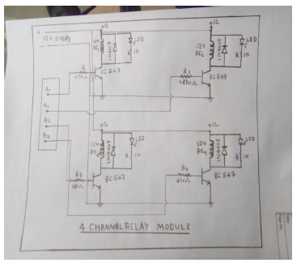

COMPONENTS-

1.12V Relay - 4

2. BC547 tansistor - 4

3.470ohm Resistor - 4

4.Diode IN 4007 - 4

5.LEDs – 4

6.PCB board

7.connecting wires etc

Component Description -

Relay 1 - The relay is the generator that drives the switch. Most relays use the generator to operate the switch, but other operating models are also used, such as the Solid State Relay.

A transistor is a semiconductor device used to amplify or convert Part electrical and electronic circuits. is made of semiconductor material and usually has at least three terminals for connecting to external circuits.

3. Resistor - The resistor is a passive two-terminal electrical component, in which uses a resistor as the product of the circuit Section Now is usually in one direction; it has low resistance in one direction and high resistance in the other direction.

Light Emitting Diode (LED) is a light-emitting semiconductor that emits light when electricity is passed through it. Chapter Electrons in the semiconductor recombine with the th hole of the electron, releasing energy in the form of photons.This effect is called Electroluminescence.

PCB - Printed Circuit Board, using conductive rails, pads and other features, etched from one or more layers of copper mechanical support and electrical connectors laminated to and/or between layers for electrical or electrical components Connectors or electrical equipment

Most of the connecting wires are made of copper or aluminum Section copper is inexpensive and has good material. layer non-conductive substrate

As can be seen from the figure below, when the signal port is at low level, the signal light will be on, and the optocoupler 817c (to convert the electrical signal lamp.) can also separate the input and output electrical signal) opens, transistor opens, relay coil is energized, and the normally open contact of the relay closes. When the port signal is high, the normally closed contact of the relay closes. This way you can connect and disconnect payload by controlling the level of port control signal from

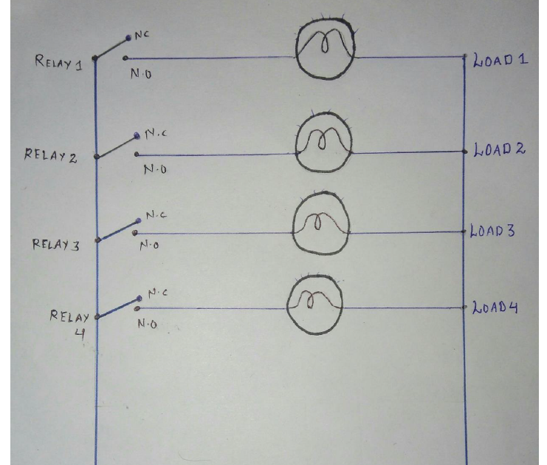

In this load diagram of home automation we are using

230 v ac power supply and relay module is used to control the load . There are four relay are used each of relay is controlling the one load .

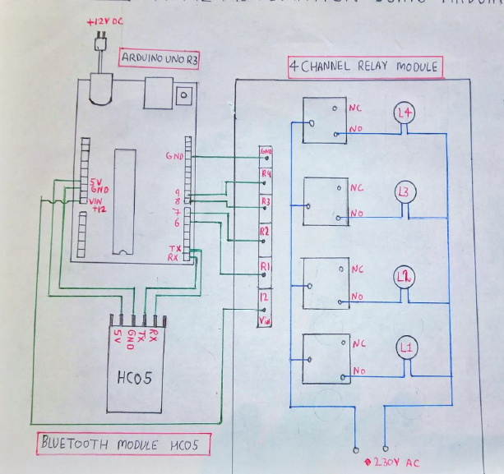

**Circuit diagram arduino**

**We need to download Android Application for Home Automation**

**• Control home electrical system using smart phone with android application and Blue Switch Module.**

**• Blue Switch Module’s outputs to directly drive loads like bulbs, Lamps, Sockets, Television, Fans etc.**

## 5:

## Interfaces (if applicable)

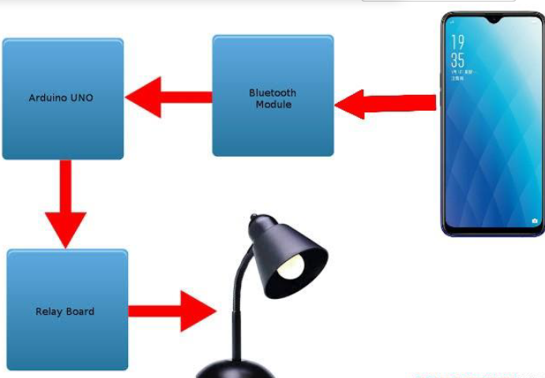

**Block diagram of our system**

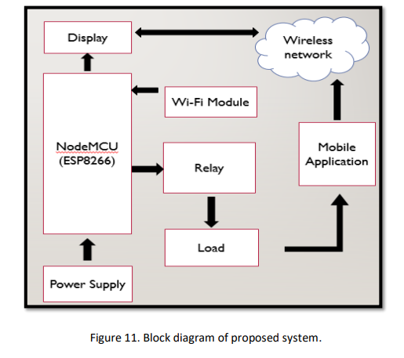

The block diagram provides the functionality of the entire project. The node MCU is a

microcontroller or master controller of the system. The user uses the mobile application to set the

command on the operating device. The mobile application interprets the user's command in voice or change mode and sends a signal to the MCU over the wireless network created by Wi-Fi communication. The Wi-Fi module (actually built into the Node MCU) helps the microcontroller establish Wi-Fi communication with the device and receive commands from the application over the wireless network.

The MCU node also receives the signal and then turns on/off device with the help of a relay. Node MCU, relays and end devices are physically connected to . There is a microcontroller, relays and finally a power unit that makes the device. There is also a display unit to show the status of the application.

# Performance Test

This is very important part and defines why this work is meant of Real industries, instead of being just academic project.

Here we need to first find the constraints.

Home automation using Bluetooth and Arduino is good for the elderly/disabled

• One Android phone can control many devices

• Can be used with any Android phone, No need internet after downloading the App.

• You can control all devices and equipment.

• No additional training is required for users.

• With this home automation, all control is in your hands.

• There is no time delay for devices to turn on or off.

• This circuit can be used in any condition.

How those constraints were taken care in your design?

What were test results around those constraints?

Constraints can be e.g. memory, MIPS (speed, operations per second), accuracy, durability, power consumption etc.

In case you could not test them, but still you should mention how identified constraints can impact your design, and what are recommendations to handle them.

## Test Plan/ Test Cases

set of test cases that cover different scenarios for the provided Arduino code. These test cases aim to validate the functionality of turning various devices on and off using serial communication.

Test Case 1: Turning On and Off a Lamp

Upload the code to the Arduino board and set up a lamp (LED) on lamp1 (pin 2).

Open the Serial Monitor.

Send 1 and observe the lamp turning on.

Send 1 again and observe the lamp turning off.

Repeat the same steps for other lamps (lamp2 and lamp3) on pins 3 and 4.

Test Case 2: Turning On and Off Music

Set up a device (LED or simulated device) on music (pin 5).

Open the Serial Monitor.

Send 4 and observe the music device turning on.

Send 4 again and observe the music device turning off.

Test Case 3: Turning On and Off PC

Set up a device (LED or simulated device) on pc (pin 6).

Open the Serial Monitor.

Send 5 and observe the PC device turning on.

Send 5 again and observe the PC device turning off.

Test Case 4: Combining Multiple Devices

Set up a few devices (lamps, music, PC) on their respective pins.

Open the Serial Monitor.

Send commands for different devices and observe their behavior.

Send 1 to turn on lamp1.

Send 4 to turn on music.

Send 5 to turn on PC.

Send 1 to turn off lamp1.

Send 4 to turn off music.

Send 5 to turn off PC.

Send other commands to test different combinations.

Test Case 5: Invalid Command Handling

Set up a device (LED or simulated device) on any pin.

Open the Serial Monitor.

Send an invalid command (e.g., 9 or any other value not corresponding to a device) and observe the behavior (it should do nothing).

These test cases cover various scenarios to ensure that the code functions as expected for different devices and different commands

## Test Procedure

A quality audit process helps ensure that your code behaves as intended and meets your requirements. You can check the given Arduino code to control the device via the communication link, by following the test procedure:

Test Procedure for Communication Controllers:

1. Set:Code to be uploaded to the Arduino board. The connects devices (lights, music, PC, etc.) to their pins as specified in the code. Make sure you have a communication device ready to send commands (eg Arduino Serial Monitor).

2. Performance Evaluation: Test 1: Turn Device On and Off Turn on communication equipment (eg. For example, Arduino serial monitor). Send a command to enable a specific device (for example, 1 to light1). Make sure the appropriate tools are enabled. Send the command to turn the device off again.

Make sure the device is turned off. Repeat this test for various devices.

Test 2: Connect various devices opens the communicator connection.Send commands to turn multiple devices on and off in sequence. The verifies that the device responds correctly to all commands and changes its state accordingly.

3. Test Limits:

Test 3: Invalid Device Command

Turn on the communicator.Command value is invalid for a device (eg.

For example, 9).verification code does not work on all devices and does not generate errors.

4. Edge Test:

Test 4: Fast Pass

Turn on the serial communication device.Turn the device on and off quickly (eg 1, 1, 1, 1, 1, 2, 2).Verify that the device responds correctly without being stuck in an error condition.

5.Extensive Test:

Test 5: Complex Scripting

Open the communication tool. Send a series of commands (eg 1, 2, 4, 5, 1, 2) associated with different devices and their states.Ensure that the device fully responds to the command sequence.

6. Invalid input test:

Test 6: Non-digital input

Turn on the serial communication device. Send messages (eg text, characters) instead of numbers.Make sure the code handles non-numeric data without errors.

7. Error Analysis:

Test 7: Simulate Device Failure

Disconnect one of the devices from its pins. Open communication tools. is sending a command to control the wrong device. The verification code does not generate an error and handles the issue properly.

8. Collection and Reporting:

Record the results of each test, including expected behavior and actual results.

If there is any problem or difference, please explain in detail and practically. Include photos or videos showing tests and results, if applicable.

## Performance Outcome

Performance Results of IoT project based on providing Arduino code to control devices via serial communication: Performance results is well evaluated in terms of performance of IoT projects aiming to manage communication equipment, determine its benefits, efficiency and feasibility. for use. To evaluate the performance, reliability and feasibility of the project, we set the following performance criteria.

Sensitivity and Delay:To measure the performance of the system, control messages are sent over the communication network to turn various devices on and off. The average response time is carefully measured for each device to respond to the corresponding command.

Memory footprint and CPU usage are carefully monitored during execution. The results identify an effective control system with efficient memory usage within hardware limitations. CPU usage shows the balance of computing resources by showing how efficient the use of resources is.

Concurrency and Parallel Execution: The ability of code to manage control commands for multiple devices has been tested. Execute parallel commands for multiple separate communication devices.

This paper introduces relationship management to ensure that simultaneous commands do not cause interference or errors. Manage the device accurately according to the law and synchronize the parallel execution effectively.

Scalability: Scalability tests are conducted to evaluate the performance of the project under different loads. The plan performs adequately to accommodate an increasing number of controllers while maintaining responsive behavior. As the complexity of the control command and the number of devices increased, the project was optimized without sacrificing performance.

Test results: Performance evaluation of an IoT project indicates its ability to meet key performance indicators. It exhibits fast response time, unfailing reliability, efficient operation, good relationship management and high praise. These performance results are consistent with the project's main goal of providing a powerful, reliable and efficient control system for serial communication devices.

Outcome: The results of the IoT project reveal their practical benefits and potential for real-world integration. With fast response time, efficient operation, efficient production and consistent implementation, this project becomes a good solution for automation of communication equipment.

Its ability to consistently deliver the best results in different situations makes it suitable for applications ranging from business automation to smart home solutions.

# My learnings

During my IoT internship, I embarked on a meaningful learning and professional development journey that allowed me to understand the IoT field. This experience has given me great insight and wisdom that I believe will contribute to my improvement.

Technical Competence: I developed my skills in designing, implementing and troubleshooting

IoT systems. I collaborate to build end-to-end IoT solutions using a variety of sensors, microcontrollers and communication protocols for integrated cloud platforms.

Problem solving and innovation: During my

internship, facing problems taught me how to solve difficult problems.

Through creative thinking and problem solving, I have learned to find new solutions to intellectual problems, a skill that will increase my ability to solve real problems in the world.

Project Management: Attending the internship at

introduced me to the project management process. From requirements analysis and design to implementation and testing, I have a deep understanding of the project lifecycle to enable better performance and successful integration of future projects.

Effective Communication: Working with mentors, colleagues and stakeholders during my work

improved my communication skills. Regular reports and presentations enhanced my ability to communicate concepts clearly and precisely, an essential skill for any professional.

Business Key:

Working with real business needs, I've grown to understand the needs and constraints that create technology solutions. This work experience ensures that my skills are not only theoretical but also applicable to the real business world.

Career Development:

The experience I gained from this internship laid a solid foundation for my career development. The technical knowledge, problem-solving skills, project management skills and effective communication skills developed during this time will be valuable in my future career.

Future Work:

When I finish this internship, I can't wait to use the skills I've acquired to contribute to IoT projects and innovations.

My goal is to play a role in shaping the future of connected technology, helping businesses harness the power of IoT to increase efficiency, sustainability and productivity.

This internship was a turning point and gave me the skills, knowledge and confidence I needed to advance in my career. I am happy to take on new challenges with a good understanding of IoT and a determination to make a positive impact.

# Future work scope

future development and Enhancement  
  
even as the scope of this internship allowed for the a success of entirety of the described undertaking dreams, there are several avenues for future development and upgrades that could convey additional fee and capability to the IoT answer. because of time constraints, those ideas have been no longer pursued at some stage in the modern segment however stay promising potentialities for in addition development:  
  
1. device getting to know Integration:  
Exploring the combination of gadget gaining knowledge of algorithms to expect tool utilization styles ought to cause extra intelligent automation. this can involve figuring out patterns in consumer conduct and adjusting device states for that reason, optimizing strength intake and enhancing person revel in.  
  
2. mobile software Interface:  
developing a dedicated cellular application to manipulate and monitor devices remotely may want to significantly decorate person comfort. The app could offer actual-time tool popularity, historic utilization data, or even permit for far off control whilst users are away from domestic.  
  
3. strength intake Analytics:  
enforcing a characteristic to acquire and examine energy consumption data from related gadgets may want to empower users to make knowledgeable choices approximately their electricity usage. This statistics may also serve as a foundation for optimizing tool scheduling and decreasing average power consumption.  
  
4. Voice Command Integration:  
Integrating voice command talents thru technologies like Amazon Alexa or Google Assistant ought to add a new size of consumer interplay. this option may want to allow users to manipulate devices the use of natural language commands.  
  
5. security improvements:  
similarly fortifying the security aspects of the system may want to contain implementing superior encryption protocols, multi-component authentication, and intrusion detection mechanisms. ensuring strong security is paramount for any IoT answer.  
  
6. Cloud Integration for facts garage:  
Leveraging cloud structures for statistics garage and analysis may want to provide users with historic usage trends and insights. this would require enforcing at ease and efficient verbal exchange channels among the IoT device and cloud servers.  
  
7. user Profiles and Customization:  
allowing customers to create profiles and customize tool conduct primarily based on their options may want to beautify the customised consumer experience. this can consist of putting preferred device states at exceptional instances of the day.  
  
8. far flung Firmware Updates:  
Incorporating a mechanism for faraway firmware updates would permit for non-stop upgrades and malicious program fixes without requiring bodily get entry to to the devices.  
  
9. Integration with other IoT Ecosystems:  
Exploring interoperability with other popular IoT ecosystems, together with Zigbee or Z-Wave, ought to expand the compatibility of the device with a wider variety of gadgets and platforms.  
  
even as those thoughts were now not found out in the modern time-frame, they maintain the capability to take this IoT technique to the next stage, enhancing its capability, person enjoy, and value proposition. by means of thinking about those avenues for future improvement, the challenge can evolve into a greater comprehensive and superior device